Order of Tightening Cylinder Head Nuts

Vern is taking a well-earned break over the holiday period, so it has fallen to me to find a snippet of tech information for this edition’s technical corner. I trolled through some of the stuff I have accumulated over time and remember finding this very handy when I was rebuilding the engine TEF. It outlines the sequence you must undo the nuts securing the head to the engine block. The picture in the copy of the manual I had was blurred and difficult to read, and the explanation in the absence of a clear picture was difficult to follow. I did know if you do not loosen and tighten the nuts securing the head to the block in the correct sequence you can risk damaging the head. I hope it might also help someone else out.
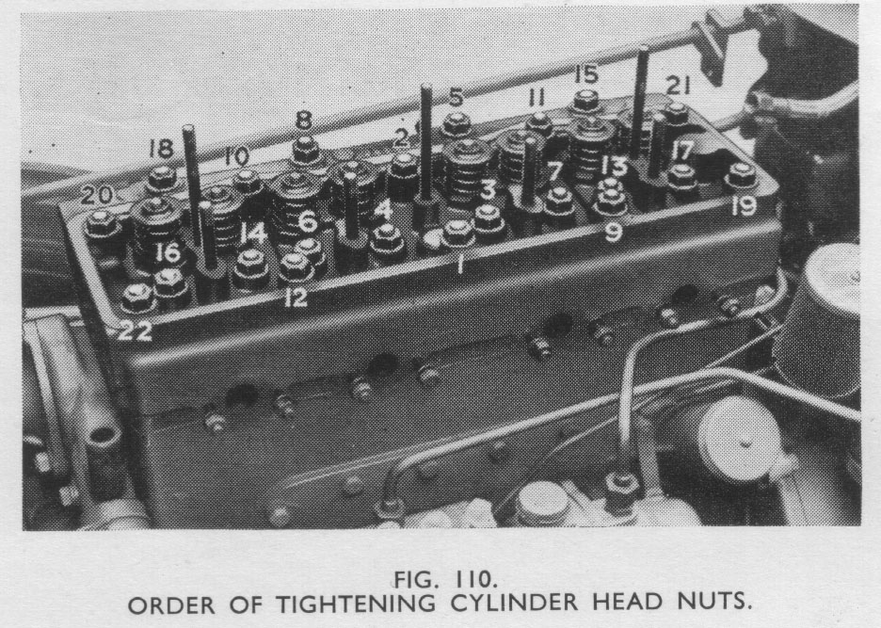

Bob Wilson

