Your Battery is flat. Maybe the generator is not working.
Your electrical system may not be up to scratch, first we must insure all connections are clean and firmly tighten. Next the drive belts, (fan belt) 1, check the condition of the crankshaft and generator pulleys. Pulleys wear on the sides to an extent that when a drive belt is placed in the groove, the belt sits on the bottom and this is evident when looking at the pulley, as the bottom of the groove \_/ is shiny. If the pulleys are worn, the drive belt will slip even when correctly tightened; the pulleys need to be replaced. 2, the drive belt tension is correct, when approximately ½ inch deflexion is obtained when applying a firm pressure to the belt between the crankshaft pulley and the generator pulley.
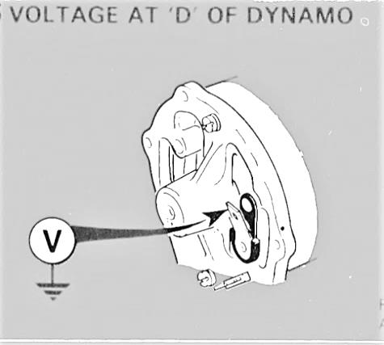
Now to check if the generator is at fault, Test one. 1. Disconnect leads from the generator 2. Connect one lead of the voltmeter (large terminal) and the other to a good earth. 3. Start engine and raise speed until the generator is running about 3000 RPM (1/2 throttle) 4. As the generator runs up to charging speed you should have a reading of 2 to 4 volts. Everything OK. (Armature and brush connections OK.
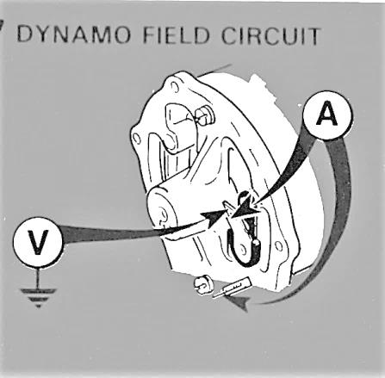
NO reading, check brushes are free in their holders and in good condition. TEST Two. 1. With the Volt meter still connected as in test one; link the D and F terminals on the generator together using an AMP meter. 2. Start engine and increase speed to a fast idle, the Amp meter should read no more than 2 Amps when the Volt meter shows system voltage of 12 Volts. 3. Rising Volts as the engine speed increases to 12 Volts and Amp meter reading approx. 2 amps all IS OK . 4. With no Voltage increase as engine speed increases or zero voltage the generator needs to be repaired or replaced.
Now that you have verified that the generator is working, reconnect the wires to generator. NEXT Remove the D and F terminals from regulator and repeat tests ONE and TWO. Connecting the VOLT meter and AMP meter to the terminals of the wires as in tests ONE and TWO your results should be the same. This confirms that wires and connections are in good order. The next issue of FergyTalk will test whether the regulator is operating correctly. You’re Tech Officer VERN.

