Polarity of the battery and the charging system.
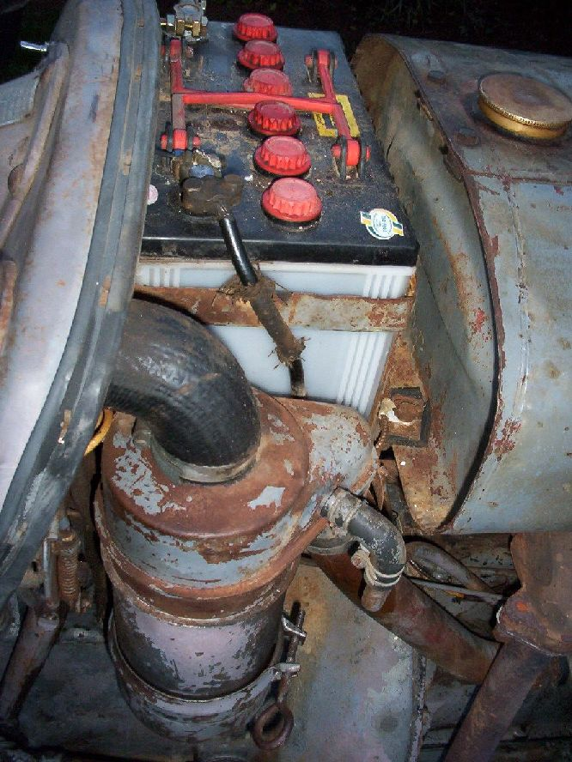
Changing of the battery earth from Positive to Negative changes the magnetic field operating within the electrical system and effects the operation the regulator cut-out and the generator. The regulator cut-out opens a set of points and prevents the battery discharging through the generator to earth when the engine is shut down. This will flatten the battery and may, in some instances, cause burnt out wiring or even a burnt tractor. Reversed polarity of the regulator cut-out may keep the cut-out points closed resulting in the above damage.
Polarisation of the electrical system is a procedure which matches the polarity of the generator and voltage regulator by permitting a surge of electrical current though the generator and regulator, thus matching the magnetic polarity of both units.
Polarising of the generator and regulator should take place whenever any of the following take place, 1. The generator is replaced or serviced. 2.The regulator is replaced or serviced. 3. Changing the Positive or Negative terminal of the battery to Earth. 4. When you fit L.E.D lights.
Polarisation of electrical system is to be carried out before starting the engine to match all units.
To accomplish this task, you will need to make yourself a jumper lead (wire) of heavier wire (14 or 16 gauge) with alligator clips on the ends, long enough to reach from the live battery terminal (which is the terminal not going to earth) to the large terminal on the generator.
Clip one end of the jumper lead to the large terminal on the generator (A) and then flash the other end of the jumper lead on the live terminal of the battery, you will get a flash of sparks when this is done but is OK. Turn on the ignition switch (petrol engines) and the charge light should show, when the engine is started and the engine speed is increased the charge light will go out indicating everything is OK. When the engine speed is decreased to idle, the light will show indicating there is no output from the generator and the electrical system working all OK. On petrol engines you will also need to check polarity of the ignition coil, (e.g.) when the battery is Positive to earth the Positive + terminal on the coil must go to the points for the coil to operate at maximum efficiency, and Negative – on coil when battery is Negative to earth.
On diesel engine tractors the Amp meter indicates if the generator is charging, however the procedure to polarise the electrical is the same, if changing the earth terminal on the tractor the wires on the Amp meter will also need to be switched over to show charge (+).
Vernon Finlay, Tech Officer.

